Welcome to Second Grade!
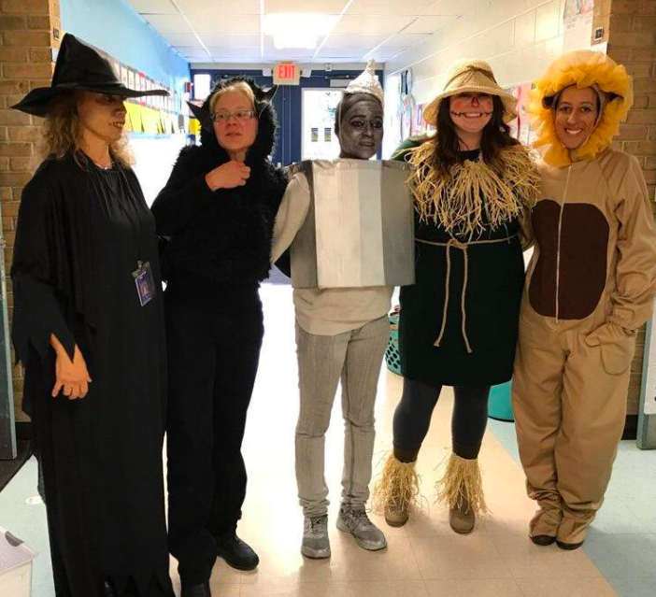
Mrs. Hahn
Room 3
Second grade is so much fun!
I’m a cat lover! At home I have two cats, Lyla and Frodo.
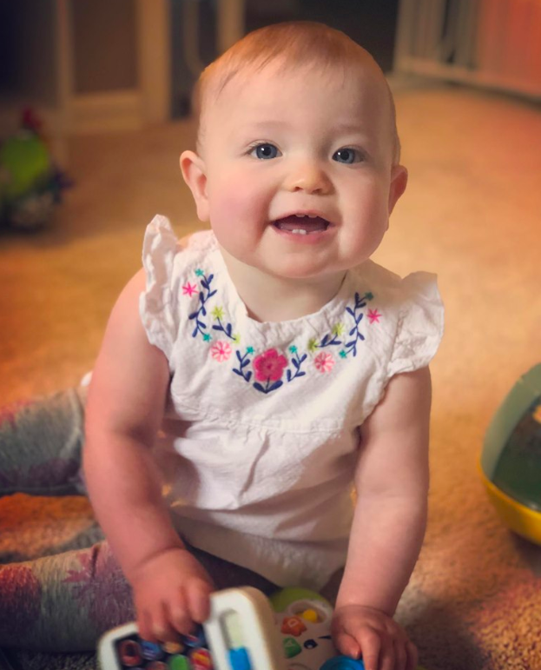

2nd Grade is SO much fun!
My daughter Coraline is nearly 10 months old!
I love to spend time with my family, including my husband and my daughter Coraline.

August 29, 2019
Dear Families,

Welcome to the 2019-2020 school year at Thurston Elementary. I am eager to get to know your child and begin building a strong relationship between home and school. Second grade is an important year for building independence and I am thrilled that we can share in this exciting time of learning. This is my third-year teaching second grade at Thurston and my sixth-year teaching elementary age students. I have loved every moment of being part of the Thurston community.

My goal for your child is to make tremendous growth academically through meaningful learning opportunities and I strongly rely on partnerships with parents / guardians to help make that happen. If at anytime you have questions please do not hesitate to contact me. It is going to be a spectacular year!

Please read all the important information below to help start the school year. The information should answer many of the questions you may already have. Additionally, detailed information will be sent home within the next few weeks and during Curriculum Night later in September.

Email – I can be reached by email at hahnk@aaps.k12.mi.us . I try to check my email several times throughout the day, so it is a great way to reach me with a non-urgent message. Please be aware that there are times when we are extremely busy and I do not get a moment to check my messages. ***If you have an urgent message, please call the office and they will notify me directly.

Flexible Seating – Our classroom is arranged in a way that allows student choice with seating. When your child arrives the the first day of school, they may have the opportunity sit at a traditional desk, wobble stool, floor cushion, exercise ball, and much more. Choice in seating allows students options for movement, collaboration, and communication throughout the day. Don’t worry if they are sitting at a spot that is not their favorite the very first day, ALL students will eventually have a choice of where they would like to sit that best suits their learning style and needs.
Supplies– To begin the school year, a list of supplies is included below that your student will need. Most, not all, supplies are used for the classroom community, meaning they are shared. Please do not write names unless otherwise specified.

- 2 packs pencils (Ticonderoga, preferred brand)
- 1 pack of erasers (rectangular & pink)
- 6 glue sticks
- 2 dry erase markers (EXPO-slim)
- 2 boxes of crayons (Crayola, preferred brand)
- 1 pair of scissors --- please label with name
- 2 composition notebooks --- please label with name on inside cover

We can always use donations of tissues, Ziploc bags (gallon size), Clorox wipes, paper towels, and band-aids. Throughout the year, I may send requests home for supplies to help aid our learning. Look for that information in our bi/weekly newsletters and emails. Thank you for supporting our classroom.
Backpacks – Please establish a DAILY routine for checking your child’s backpack and home folder. The folder will be used as a communication tool between teachers and parents, as well as a means to conduct paperwork for school.
Transportation- Please complete the attached student information form regarding transportation your child intends on taking to and from school. This will be especially helpful in eliminating any confusion for the first day. If transportation changes, please send me a quick note or email. This will ensure your child arrives to you safely.
Arrival- When arriving to school, students may wait outside the side doors (right of the office, by the playground). Students may enter the building after the first bell. All students should stand quietly outside his/her classroom until 8:56am until they hear the second bell. Parents/guardians may help their child get settled in the classroom the first day of school during our morning routine. Beginning Wednesday, I will be asking all parents to give their goodbyes at the door and allow their child to enter the classroom on his/her own. We are working on building independence and will start practicing right away. I truly appreciate your support!

Snack – There will be a designated daily morning snack time for all students. There may be students with food allergies in our classroom and we’ll need to be sensitive to their needs. Once I am aware of our need, I will notify parents of any restrictions we will have. At this moment, we are a NUT FREE classroom. Typically, parents/guardians are asked to provide their child with one small and healthy snack (pretzels, fruit, cut vegetables, yogurt, crackers, cheese, etc.) Bulk classroom snack donations are welcomed and appreciated.

Lunch- Students have an option to bring a lunch or buy lunch. Any purchasing of lunches or lunch related items will be handled by the office staff. Your child will be asked EVERY DAY in class if he/she will be receiving a school lunch. If he/she says “yes” your account will be charged accordingly. To add more money to your account, stop by the office and they will take care of you.

Dismissal – At 3:59 pm, I will bring the students outside the double doors by the second-grade playground. If picking up, please plan to meet in a designated space (ex, flag pole). Students riding a bus home will be grouped together and sent outside. Students attending after school care will walk to their designated spot/classroom.
__________________________________
I hope I have answered many of your questions. Moving forward, open communication is very important to me and I seek to keep you as informed as possible.

I look forward to a great second-grade year at Thurston!

Warmly,
Mrs. Hahn

